

**IOT SMART OFFICE SIMULATION**

**A CAPSTONE PROJECT REPORT**

*Submitted in the partial fulfilment for the Course of*

**CSA0735 – Computer Networks for communication**

*to the award of the degree of*

**BACHELOR OF ENGINEERING**

*IN*

**CSE,AIDS**

**Submitted by**

|  |  |
| --- | --- |
| **Adusuru harsha vardhan** | **192524212** |
| **Dhanshika** | **192511139** |
| **Arshiya** | **192512093** |

**Under the Supervision of**

**Dr. RAJARAM P**

**SIMATS ENGINEERING**

**August 2025**



**DECLARATION**

We, **Adusuru harsha Vardhan 192524212, Dhanshika 192511139, Arshiya 192511137** of the **CSE**,**AIDS S**aveetha Institute of Medical and Technical Sciences, Saveetha University, Chennai, hereby declare that the Capstone Project Work entitled **IOT SMART OFFICE SIMULATION** is the result of our own bonafide efforts. To the best of our knowledge, the work presented here in is original, accurate, and has been carried out in accordance with principles of engineering ethics.

**Place :**

**Date :**

|  |  |  |
| --- | --- | --- |
| **Name of the Student** | **Register No** | **Signature** |
| **Adusuru harsha vardhan** | **192524212** |  |
| **Dhanshika** | **192511137** |  |
| **Arshiya** | **192511137** |  |



**BONAFIDE CERTIFICATE**

This is to certify that the Capstone Project entitled “**IOT SMART OFFICE SIMULATION**” has been carried out by **Adusuru harsha Vardhan , Dhanshika, Arshiya** under the supervision of **Dr Hemavathi R** and is submitted in partial fulfilment of the requirements for the current semester of the B.Tech **CSE, AIDS** program at Saveetha Institute of Medical and Technical Sciences, Chennai.

|  |  |
| --- | --- |
| **SIGNATURE**  Name of the Program Director  Program Director  Department Name (Branch)  Saveetha School of Engineering  SIMATS | **SIGNATURE**  Name of the Guide  Designation  Department Name (Branch)  Saveetha School of Engineering  SIMATS |

Submitted for the Project work Viva-Voce held

on_________________

**INTERNAL EXAMINER EXTERNALEXAMINER**

**ACKNOWLEDGEMENT**

We would like to express our heartfelt gratitude to all those who supported and guided us throughout the successful completion of our Capstone Project. We are deeply thankful to our respected Founder and Chancellor, **Dr. N.M. Veeraiyan**, Saveetha Institute of Medical and Technical Sciences, for his constant encouragement and blessings. We also express our sincere thanks to our Pro-Chancellor, **Dr. Deepak Nallaswamy Veeraiyan**, and our Vice-Chancellor, Dr. S. Suresh Kumar, for their visionary leadership and moral support during the course of this project.

We are truly grateful to our Director, **Dr. Ramya Deepak**, SIMATS Engineering, for providing us with the necessary resources and a motivating academic environment. Ours special thanks to our Principal, **Dr. B. Ramesh** for granting us access to the institute’s facilities and encouraging us throughout the process. We sincerely thank our Head of the Department, **Dr. Sriramya** or his continuous support, valuable guidance, and constant motivation.

We are especially indebted to our guide, **Dr Rajaram P** for his creative suggestions, consistent feedback, and unwavering support during each stage of the project. We also express our gratitude to the Project Coordinators, Review Panel Members (Internal and External), and the entire faculty team for their constructive feedback and valuable inputs that helped improve the quality of our work. Finally, we thank all faculty members, lab technicians, our parents, and friends for their continuous encouragement and support.

|  |  |
| --- | --- |
| **Adusuru harsha vardhan** | **192524212** |
| **Dhanshika** | **192511137** |
| **Arshiya** | **192511137** |

**IOT SMART OFFICE SIMULATION**

**ABSTRACT:**

The rapid advancement of the Internet of Things (IoT) has paved the way for smarter and more efficient workspaces. This project presents the design and simulation of an IoT-based Smart Office System that automates and optimizes common office operations such as lighting control, access management, energy monitoring, and security surveillance. By integrating various sensors and actuators into a centralized control system, the simulation demonstrates how IoT technology can improve energy efficiency, enhance workplace security, and reduce the need for manual intervention.

The system is implemented and tested in a simulated environment using tools like Cisco Packet Tracer (or equivalent platforms), enabling the replication of real-time scenarios such as motion-triggered lighting, RFID-based access control, and temperature-based ventilation. The project highlights the potential of IoT in reshaping traditional office environments into intelligent, responsive, and remotely manageable systems. This simulation serves as a foundational model for future expansions into fully deployed smart office infrastructure.

**📖 Chapter 1: Introduction**

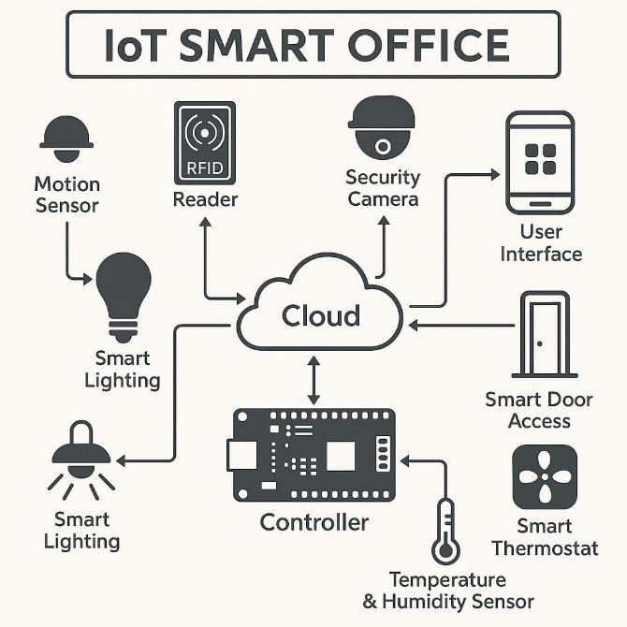

**1.1 Overview:**

IoT (Internet of Things) is transforming how offices operate by automating lighting, temperature, access control, security, and energy management.

A Smart Office Simulation replicates this using virtual or real-world components to show efficiency, automation, and security.

**1.2 Problem Statement:**

* Traditional offices waste energy, lack security, and depend heavily on human operation.
* A smart IoT-based system solves this with automation and centralized control.
* Automate office processes (lighting, security, HVAC, etc.)

**1.3 Objectives:**

* Improve energy efficiency and reduce human intervention.
* Simulated environment using sensors, actuators, and control
* **Covers access control, smart lightning, security system.**

**📖 Chapter 2: Literature Review**

**2.1 Related Work:**

* Summary of other smart office systems.
* Existing solutions using platforms like Arduino, Node MCU, Blynk, Cisco Packet Tracer, etc.

**2.2 Technologies Used in Smart Offices:**

* IoT protocols: MQTT, HTTP, CoAP
* Communication: Wi-Fi, ZigBee, Bluetooth
* Sensors: PIR, RFID, Temperature, Motion

**2.3 Gap Analysis:**

* Most existing systems focus on one or two components (e.g., lighting or security only).
* Your simulation combines multiple modules for a complete smart office experience.

**📖 Chapter 3: System Analysis**

**3.1 Feasibility Study:**

* Technical: Possible using simulations or low-cost hardware.
* Economic: Cost-effective using open-source tools.
* Operational: Reduces energy consumption, increases productivity.

**3.2 Requirements:**

* Hardware (if physical): Arduino/Node MCU, Sensors (PIR, RFID), Relays, LED, Camera.
* Software: Cisco Packet Tracer (or Tinker CAD, Blynk), Arduino IDE, Mobile App (optional) Motion-activated smart lighting using PIR sensors
* RFID-based door access system for employee authentication
* Temperature-controlled HVAC using DHT sensors and relays

**📖 Chapter 4: System Design**

**4.1 Architecture Diagram:**

(You can use a block diagram showing sensors > controller > cloud/server > mobile/PC)

**4.2 Module Description:**

1. Smart Lighting – PIR motion sensor turns lights on/off based on presence.

2. Access Control – RFID/NFC card for employee entry.

3. Surveillance – Camera module or simulation of CCTV.

4. Energy Monitoring – Sensors track usage of AC, lights, etc.

5. Temperature Control – DHT11/22 sensor triggers fan/AC.

**4.3 Flowchart:**

Show the decision-making process (e.g., IF motion detected → turn light ON)

**📖 Chapter 5: Implementation**

**5.1 Tools Used:**

* Cisco Packet Tracer or Tinker CAD for simulation
* Arduino IDE (if using real hardware)
* Blynk app for remote monitoring

**5.2 Code Snippets:**

* Include short, clear code examples for each module.

**5.3 Simulation Screenshots:**

* Add screenshots from Packet Tracer or other platforms to show working modules. 5.3 Network Design
* Devices are connected through Wi-Fi or virtual IoT gateways.
* All modules communicate with a central controller or cloud.
* Data flow is managed via MQTT or HTTP requests.

**📖 Chapter 6: Results and Discussion**

**6.1 Outputs:**

* Show how lights respond to motion, RFID grants access, etc.
* Data showing energy saved or system performance

**6.2 Advantages:**

* Energy efficiency
* Increased security
* Automation and comfort

**6.3 Limitations:**

* Depends on internet/network reliability
* Simulated system may not fully match real-world complexity

**📖 Chapter 7: Conclusion and Future Work**

**7.1 Conclusion:**

* Summarize what was achieved
* Benefits observed from simulation

**7.2 Future Enhancements:**

* Integrate AI for learning-based automation
* Add voice control using Google Assistant or Alexa
* Real Hardware Implementation

Real Hardware Implementation:

Move from simulation to a physical prototype using Arduino/ESP32 and actual sensors and relays.

**7.3 Cloud-Based Analytics Dashboard:**

Real-time data visualization and trend analysis using platforms like Power BI, Grafana, or Google Data Studio.

**📘 Chapter 8: References**

This chapter lists all the sources, tools, and literature that you used throughout the project. Use a consistent referencing style (e.g., APA, IEEE).

**8.1 Example References:**

1. Arduino.cc – Official Arduino Documentation

2. Blynk.io – IoT Platform for Mobile App Integration

3. "Internet of Things: A Hands-On-Approach" – Arshdeep Bahga & Vijay Madisetti

4. Cisco Packet Tracer Simulation Tutorials – Cisco Networking Academy

5. Thing Speak Documentation

6. DHT11 Sensor Datasheet

7. Research Paper: “Smart Office Automation using IoT” – IEEE, 2020

8. YouTube Channel: Techiesms – IoT Simulation Tutorials

**📘 Chapter 9: Appendix**

**The appendix includes supporting documents or files that are too long to include in the main body but are important to the project.**

**9.1 Items You Can Include:**

* Full source code for each module
* Screenshot of circuit connections/simulations
* List of hardware components with specifications
* Mobile app screenshots (if using Blynk or MIT App Inventor)
* Sample sensor readings/data logs
* Diagrams not included earlier (like wiring diagrams)

**📘 Chapter 10: Glossary**

This section explains technical terms and abbreviations used in your project. Keep it short and clear.

**10.1 Sample Terms:**

* IoT: Internet of Things – network of connected physical devices.
* RFID: Radio Frequency Identification – used for access control.
* PIR Sensor: Passive Infrared Sensor – detects motion.
* MQTT: Message Queuing Telemetry Transport – lightweight communication protocol.
* HVAC: Heating, Ventilation, and Air Conditioning.
* Node MCU: An open-source IoT board with Wi-Fi capability.
* Cloud: Remote server storage used for data and analytics.
* Simulation: Virtual model that mimics real-world behavior.

**📘 Chapter 11: Smart Modules**

**11.1. Smart Meeting Room Booking System:**

* **Uses IR sensors to detect room occupancy**
* **Syncs with a calendar system to book or cancel rooms automatically**
* **Displays current availability on an LED screen outside the room**

**11.2. Smart Desk Management:**

* **Pressure sensors detect if a desk is occupied**
* **Employees can find free desks using an app**
* **Useful for hybrid or co-working office spaces**

**✅ Technology Features:**

* **Sensors: PIR, RFID, DHT11, MQ135, LDR**
* **Actuators: Relay modules, Servo motors, LEDs, Buzzers**
* **Boards: Arduino Uno, Node MCU ESP8266, ESP32**
* **Protocols: MQTT, HTTP, IFTTT, Wi-Fi**
* **Platforms: Blynk, Thing Speak, MIT App Inventor**

**✅ Security Enhancements**

* **All device data encrypted using SSL/TLS**
* **Authentication layer in app for admin-only access**
* **Logs stored with timestamps for accountability**

**✅ Simulation-Based Use Case Scenarios**

**1. Morning Routine:**

* **RFID tag used to open door**
* **Lights and AC turn ON**
* **Attendance marked automatically**

**2. Idle Room Handling:**

* **No motion for 10 mins → Lights & AC turn Off.**
* **Smoke or gas detected and sends alert to the admin.**
* **Unauthorized entry attempt,it triggers alarm and mobile notification**
* **Adjust the temperatures and exceed limits and adjust the AC and notify users.**

**Step 1: Requirement Finalization**

* **Identified the core smart office features: smart lighting, RFID access control, temperature monitoring, energy management, and optional add-ons like surveillance.**
* **Selected simulation tools: Cisco Packet Tracer and Tinker CAD for virtual circuit and logic testing.**

**✔️ Step 2: System Design**

* **Designed a block diagram showing the communication between sensors, actuators, controllers, and cloud interface.**
* **Created individual module diagrams for each function like lighting, access control, and HVAC automation.**

**✔️ Step 3: Code Development**

* **Wrote Arduino-based logic for each module:**
* **PIR sensor for motion-triggered lighting**
* **RFID reader for access control**
* **DHT11 sensor for temperature-based automation**
* **Tested the code using Tinker CAD simulation and verified working conditions.**

**✔️ Step 4: Simulation Testing:**

* **Created simulation in Cisco Packet Tracer showing device interaction using IoT servers.**
* **Each module (lighting, access control, temperature, etc.) is tested individually before integration**

**IOT SMART OFFICE SIMULATION**

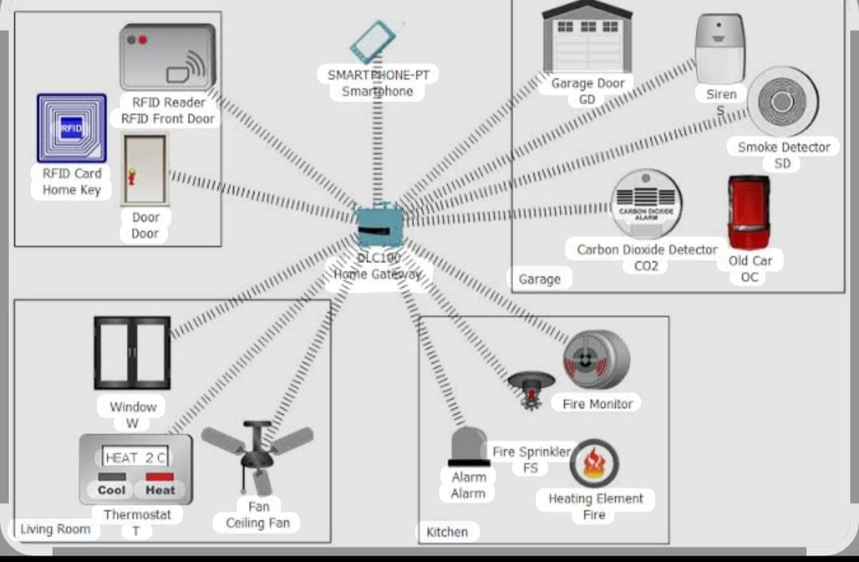

**📌 Chapter 12: Conclusion**

**The IoT Smart Office Simulation project demonstrates how smart technologies can be integrated into an office environment to increase efficiency, energy savings, and employee comfort.**

**By simulating modules like smart lighting, RFID-based access control, temperature monitoring, and motion sensors, the project showcases how automation improves workplace operations.**

**The architecture design highlights real-time communication between sensors, cloud, and user interfaces, making office management seamless and intelligent.**

**IoT in offices reduces human intervention in routine tasks and helps monitor environment conditions for productivity enhancement.**

**Future enhancements may include integration of AI for predictive analytics, advanced security through biometrics, and green building automation.**

**Overall, this simulation lays the foundation for smart, sustainable, and scalable office automation.**

**📚 References:**

**1. “Internet of Things: Principles and Paradigms” – Rajkumar Buvya Amir Vahid Dast jerdi.**

**2. “IoT: A Beginner’s Guide” – Jeeva Jose, Khanna Publishing.**

**3. IEEE Papers on IoT Smart Buildings and Automation Systems**

**4. “IoT-based Smart Office Automation” – International Journal of Engineering Research & Technology (IJERT), 2020.**

**5. Arduino, Node MCU, and Raspberry Pi Official Documentation**

**6. Cisco IoT Architecture White Paper – Cisco.com**

**7. Smart Office Automation Projects – Projects on ResearchGate.net**

**8. YouTube tutorials on Smart Office Simulations using Blynk, Tinker cad, or Proteus**